1.start the all daemons and check whether daemons are started or not.

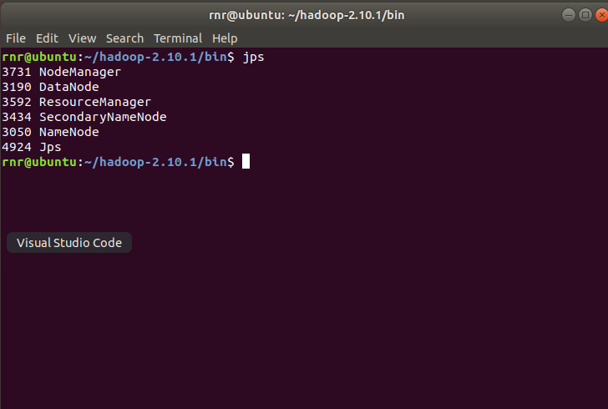

2.Create a new directory called revenue, inside directory called sales in one command.

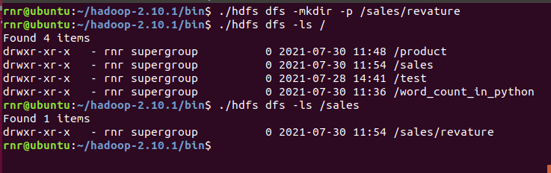

3.Copy the existing file into the revenue directory.

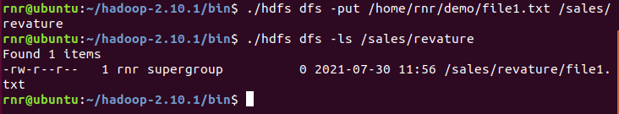

4.Create a directory called product, copy all files in any folder from your local disk into the hdfs directory product.

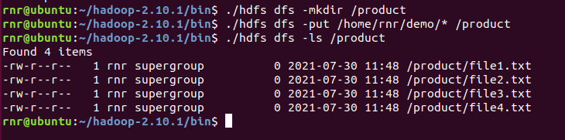

5.list the files from the product directory and view the content of the file in the revenue directory.

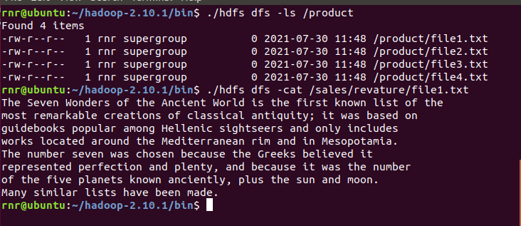

6.Download the files from HDFS directory called product and cop into localhost directory called input.

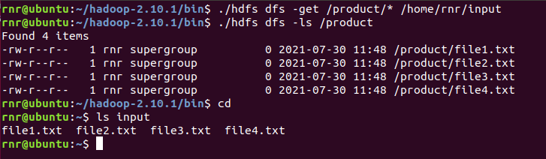

7.Merge two files using HDFS commands.

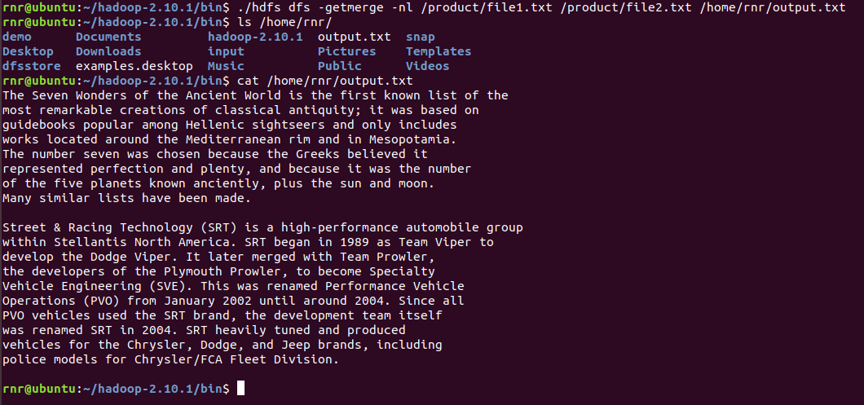

8.Move revenue directory to product directory in hdfs.

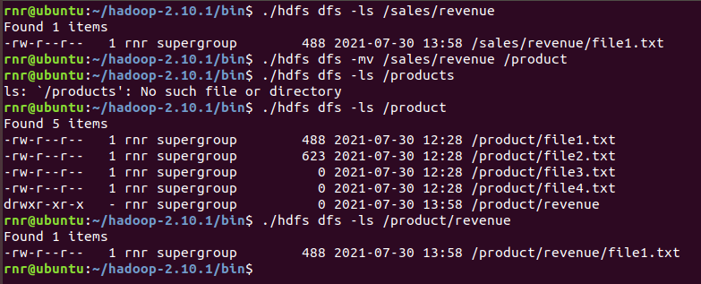

9.Remove sales directory from hdfs.

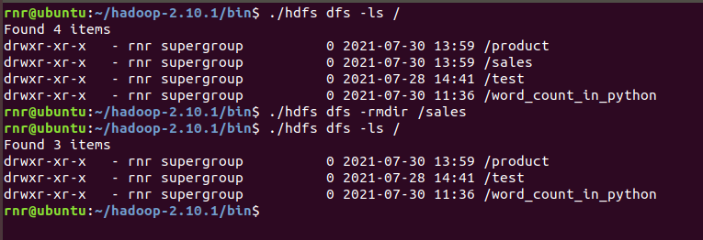

10.Display last kilobyte of the file.

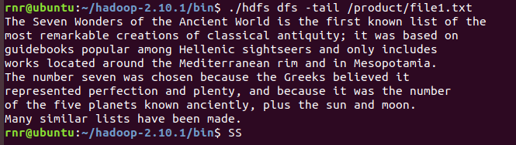

11.Check the working processess files in hdfs.

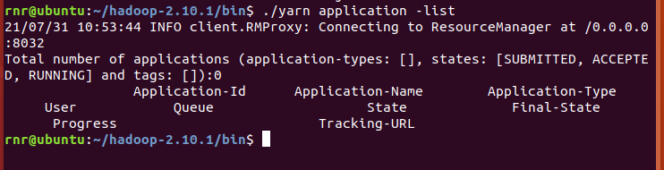

12.Different varieties of working with namenode.

**🡪 Stores metadata of actual data. E.g., Filename, Path, No. of Data Blocks, Block IDs, Block Location, No. of Replicas, Slave related configuration  
🡪 Manages File system namespace.  
🡪 Regulates client access request for actual file data file.  
🡪 Assign work to Slaves (DataNode).  
🡪Executes file system name space operation like opening/closing files, renaming files and directories.  
🡪 As Name node keep metadata in memory for fast retrieval, the huge amount of memory is required for its operation. This should be hosted on reliable hardware.**

13.List the variety of permissions.

**Hadoop distributed file system (HDFS) uses a specific permissions model for files and directories. Following user levels are used in HDFS**

**🡪Owner**

**🡪Group**

**🡪Others**

**For each of the user mentioned above following permissions are applicable,**

**🡪read (r)**

**🡪write (w)**

**🡪execute(x)**

14.Display all the process in your localhost.

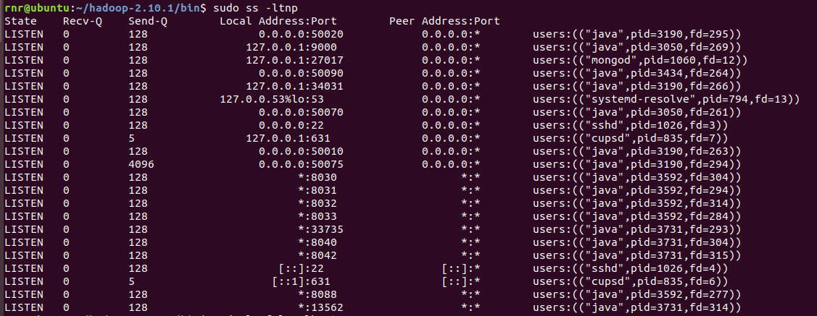

15.Stop a running job.

**We can do it by using the kill command along with the process ID (PID).**

**E.g.: - kill 10203**

**In Hadoop, we can kill the process**

**yarn application -kill 1234 (1234 is the PID)**

16.View the process which is run in specific user.

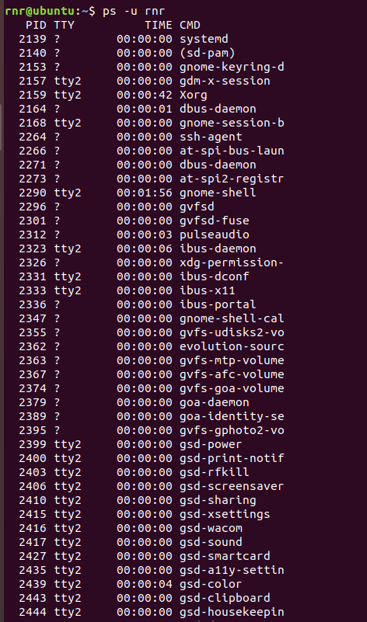

17.Use setrep command to change replication factor of the file.

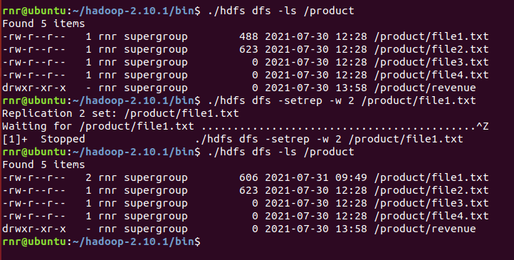

18.Append the existing file from local host to hdfs.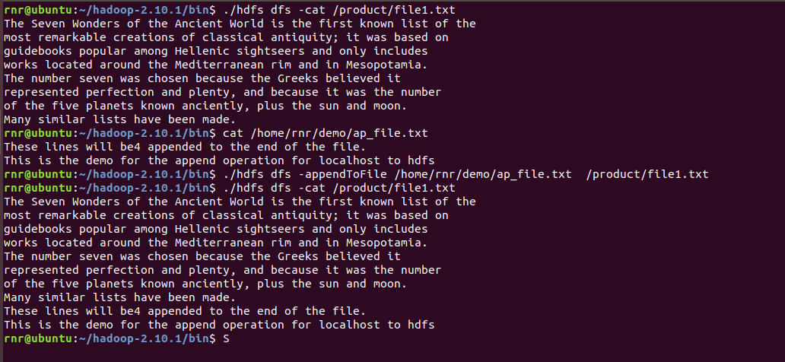

19.How to refesh a nodes.



20.How to change namenode to safemode.

